**"Pizza_Sales_MySQL_Query_results”**

**/* Q1. Find out the total revenue */**

SELECT ROUND(SUM(total_price),2) AS total_revenue FROM pizzasales;

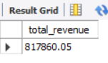

**/* Q2. What is the average order value ? */**

SELECT ROUND((SUM(total_price)/COUNT(DISTINCT(order_id))),2) AS average_order_value FROM pizzasales;

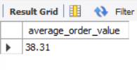

**/* Q3. Find out the total number of pizza's sold */**

SELECT SUM(quantity) AS total_pizza_sold FROM pizzasales;

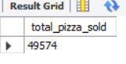

**/* Q4. Find out the total number of orders placed */**

SELECT COUNT(DISTINCT(order_id)) AS total_orders_placed FROM pizzasales;

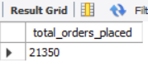

**/* Q5. Find out the average number of pizza's sold per order placed */**

SELECT ROUND((SUM(quantity) / COUNT(DISTINCT(order_id))),2) AS avg_num_pizza_sold_per_order FROM pizzasales;

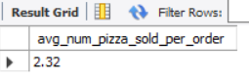

-- KPI's QUERY COMPLETED –

-- QUERIES REQUIRED FOR CHART CREATIONS –

**/* Q1. What is the hourly trend of the total pizza's sold, total orders placed & total revenue generated */**

SELECT HOUR(STR_TO_DATE(order_time,'%T')) AS order_hours,

SUM(quantity) AS total_pizza_sold,

COUNT(DISTINCT(order_id)) AS total_orders_placed,

ROUND(SUM(total_price),2) AS total_revenue

FROM pizzasales

GROUP BY order_hours

ORDER BY order_hours ASC;

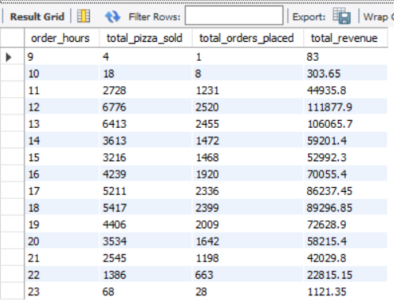

**/* Q2. What is the daily trend of the total pizza's sold, total orders placed & total revenue generated - day name */**

SELECT WEEKDAY(STR_TO_DATE(order_date,'%d-%m-%Y')) AS order_day_number,

DAYNAME(STR_TO_DATE(order_date,'%d-%m-%Y')) AS order_day_name,

SUM(quantity) AS total_pizza_sold,

COUNT(DISTINCT(order_id)) AS total_orders_placed,

ROUND(SUM(total_price),2) AS total_revenue

FROM pizzasales

GROUP BY order_day_number

ORDER BY order_day_number;

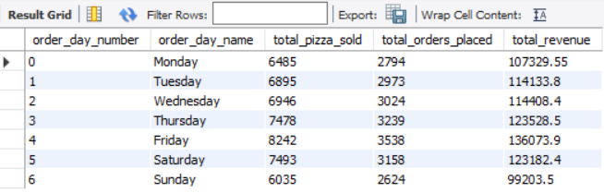

**/* Q3. What is the daily trend of the total pizza's sold, total orders placed & total revenue generated - day of month */**

SELECT DAYOFMONTH(STR_TO_DATE(order_date,'%d-%m-%Y')) AS order_day_of_month,

SUM(quantity) AS total_pizza_sold,

COUNT(DISTINCT(order_id)) AS total_orders_placed,

ROUND(SUM(total_price),2) AS total_revenue

FROM pizzasales

GROUP BY order_day_of_month

ORDER BY order_day_of_month;

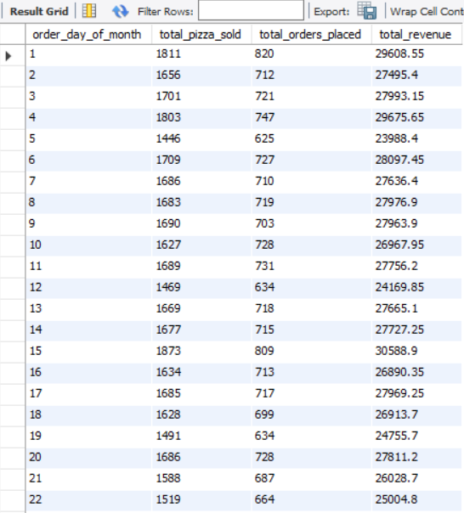

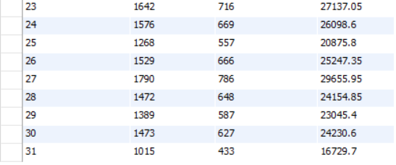

**/* Q4. What is the weekly trend of the total pizza's sold, total orders placed & total revenue generated */**

SELECT WEEKOFYEAR(STR_TO_DATE(order_date,'%d-%m-%Y')) AS order_week,

YEAR(STR_TO_DATE(order_date,'%d-%m-%Y')) AS order_year,

SUM(quantity) AS total_pizza_sold,

COUNT(DISTINCT(order_id)) as total_orders_placed,

ROUND(SUM(total_price),2) AS total_revenue

FROM pizzasales

GROUP BY order_week, order_year

ORDER BY order_week, order_year ASC;

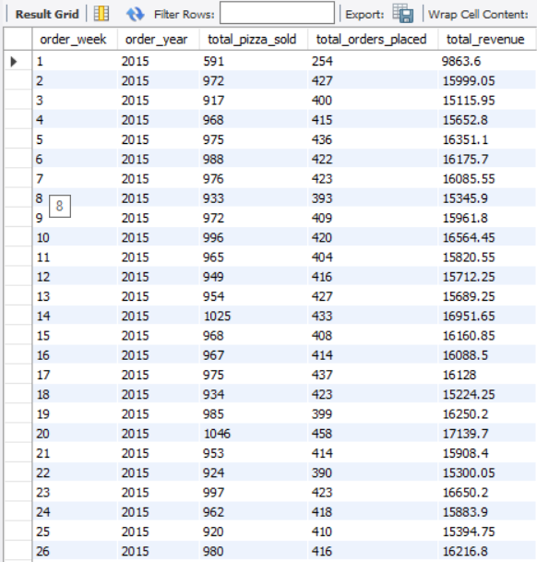

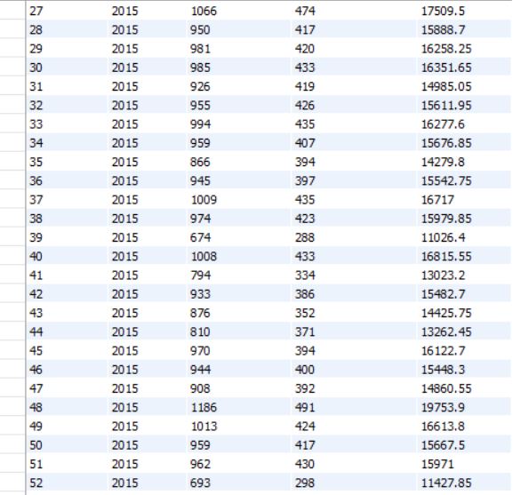



**/* Q5. What is the monthly trend of the total pizza's sold, total orders placed & total revenue generated */**

SELECT MONTH(STR_TO_DATE(order_date,'%d-%m-%Y')) AS order_month_number,

MONTHNAME(STR_TO_DATE(order_date,'%d-%m-%Y')) AS order_month_name,

YEAR(STR_TO_DATE(order_date,'%d-%m-%Y')) AS order_year,

SUM(quantity) AS total_pizza_sold,

COUNT(DISTINCT(order_id)) as total_orders_placed,

ROUND(SUM(total_price),2) AS total_revenue

FROM pizzasales

GROUP BY order_month_number, order_month_name, order_year

ORDER BY order_month_number, order_month_name, order_year ASC;

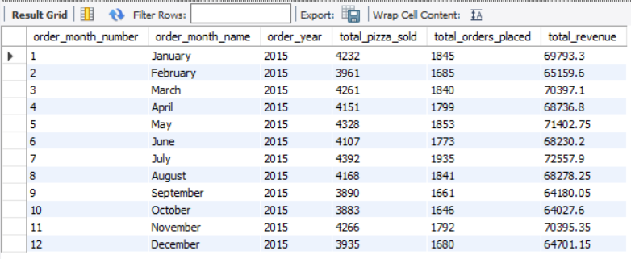

**/* Q6. What is the quarterly trend of the total pizza's sold, total orders placed & total revenue generated */**

SELECT QUARTER(STR_TO_DATE(order_date,'%d-%m-%Y')) AS order_quarter_number,

YEAR(STR_TO_DATE(order_date,'%d-%m-%Y')) AS order_year,

SUM(quantity) AS total_pizza_sold,

COUNT(DISTINCT(order_id)) as total_orders_placed,

ROUND(SUM(total_price),2) AS total_revenue

FROM pizzasales

GROUP BY order_quarter_number, order_year

ORDER BY order_quarter_number, order_year ASC;

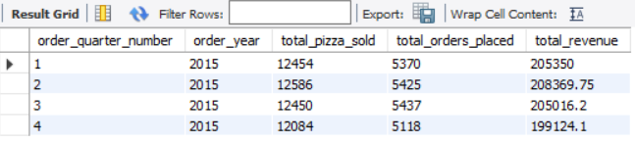

**/* Q7. What are the total orders, total quantity sold, total revenue generated & percentage of pizza sales by pizza category */**

SELECT pizza_category,

COUNT(DISTINCT(order_id)) AS total_orders_placed,

SUM(quantity) AS total_pizza_sold,

ROUND(SUM(total_price),2) AS total_revenue,

ROUND((SUM(total_price) * 100)/ (SELECT SUM(total_price) FROM pizzasales),2) AS percent_pizza_sales

FROM pizzasales

GROUP BY pizza_category

ORDER BY percent_pizza_sales DESC;

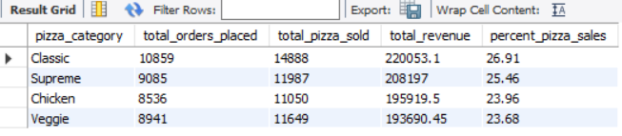

**/* Q8. What are the total orders, total quantity sold, total revenue generated & percentage of pizza sales by pizza size */**

SELECT pizza_size,

COUNT(DISTINCT(order_id)) AS total_orders_placed,

SUM(quantity) AS total_pizza_sold,

ROUND(SUM(total_price),2) AS total_revenue,

ROUND((SUM(total_price) * 100)/ (SELECT SUM(total_price) FROM pizzasales),2) AS percent_pizza_sales

FROM pizzasales

GROUP BY pizza_size

ORDER BY percent_pizza_sales DESC;

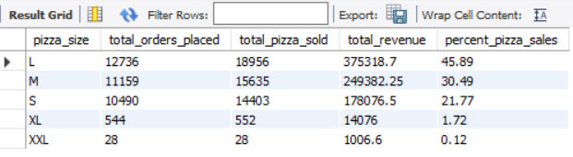

**/* Q9. What are the total orders, total quantity sold, total revenue generated & percentage of pizza sales by pizza category & pizza size */**

SELECT pizza_category,

pizza_size,

COUNT(DISTINCT(order_id)) AS total_orders_placed,

SUM(quantity) AS total_pizza_sold,

ROUND(SUM(total_price),2) AS total_revenue,

ROUND((SUM(total_price) * 100)/ (SELECT SUM(total_price) FROM pizzasales),2) AS percent_pizza_sales

FROM pizzasales

GROUP BY pizza_category, pizza_size;

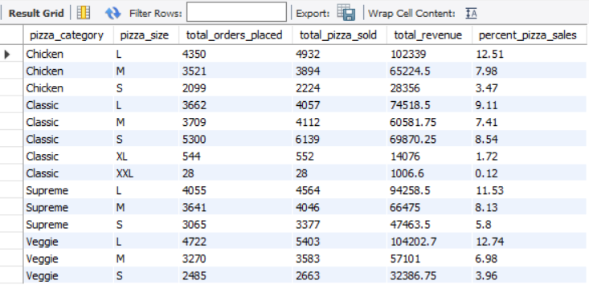

**/*NOTE: We can use WHERE clause in above three queries to get monthly, quarterly, daily, hourly data also if required**

**in order to do that add the same WHERE clause to the SELECT statement in the parenthesis also**

**Below is one example of above query 7 for January Month */**

SELECT pizza_category,

COUNT(DISTINCT(order_id)) AS total_orders_placed,

SUM(quantity) AS total_pizza_sold,

ROUND(SUM(total_price),2) AS total_revenue,

ROUND((SUM(total_price) * 100)/ (SELECT SUM(total_price) FROM pizzasales

WHERE MONTH(STR_TO_DATE(order_date,'%d-%m-%Y')) = 1),2) AS percent_pizza_sales

FROM pizzasales

WHERE MONTH(STR_TO_DATE(order_date,'%d-%m-%Y')) = 1

GROUP BY pizza_category;

**/* Q10. What are the total orders, total quantity sold, total revenue generated categorized by pizza name - Top 5 by total revenue */**

SELECT pizza_name,

COUNT(DISTINCT(order_id)) AS total_orders_placed,

SUM(quantity) AS total_pizza_sold,

ROUND(SUM(total_price),2) AS total_revenue

FROM pizzasales

GROUP BY pizza_name

ORDER BY total_revenue DESC LIMIT 5;

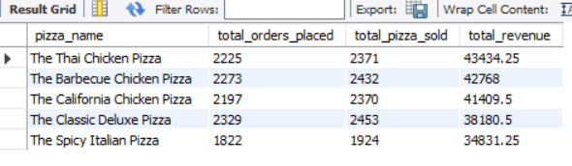

**/* Q11. What are the total orders, total quantity sold, total revenue generated categorized by pizza name - Bottom 5 by total revenue */**

SELECT pizza_name,

COUNT(DISTINCT(order_id)) AS total_orders_placed,

SUM(quantity) AS total_pizza_sold,

ROUND(SUM(total_price),2) AS total_revenue

FROM pizzasales

GROUP BY pizza_name

ORDER BY total_revenue ASC LIMIT 5;

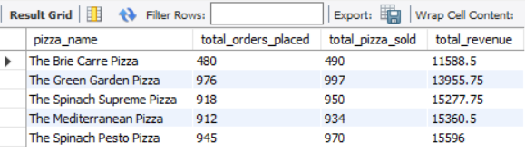

**/* Q12. What are the total orders, total quantity sold, total revenue generated categorized by pizza name - Top 5 by quantity sold */**

SELECT pizza_name,

COUNT(DISTINCT(order_id)) AS total_orders_placed,

SUM(quantity) AS total_pizza_sold,

ROUND(SUM(total_price),2) AS total_revenue

FROM pizzasales

GROUP BY pizza_name

ORDER BY total_pizza_sold DESC LIMIT 5;

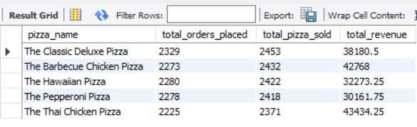

**/* Q13. What are the total orders, total quantity sold, total revenue generated categorized by pizza name - Bottom 5 by quantity sold */**

SELECT pizza_name,

COUNT(DISTINCT(order_id)) AS total_orders_placed,

SUM(quantity) AS total_pizza_sold,

ROUND(SUM(total_price),2) AS total_revenue

FROM pizzasales

GROUP BY pizza_name

ORDER BY total_pizza_sold ASC LIMIT 5;

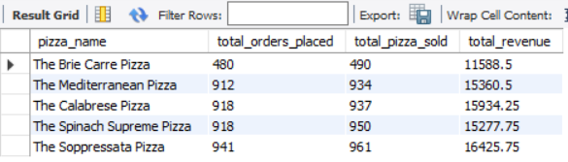

**/* Q14. What are the total orders, total quantity sold, total revenue generated categorized by pizza name - TOP 5 by orders placed */**

SELECT pizza_name,

COUNT(DISTINCT(order_id)) AS total_orders_placed,

SUM(quantity) AS total_pizza_sold,

ROUND(SUM(total_price),2) AS total_revenue

FROM pizzasales

GROUP BY pizza_name

ORDER BY total_orders_placed DESC LIMIT 5;

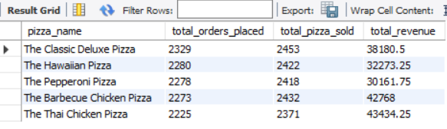

**/* Q15. What are the total orders, total quantity sold, total revenue generated categorized by pizza name - Bottom 5 by orders placed */**

SELECT pizza_name,

COUNT(DISTINCT(order_id)) AS total_orders_placed,

SUM(quantity) AS total_pizza_sold,

ROUND(SUM(total_price),2) AS total_revenue

FROM pizzasales

GROUP BY pizza_name

ORDER BY total_orders_placed ASC LIMIT 5;

